Assignment -4

Docker and Kubernetes

|  |  |
| --- | --- |
| Assignment Date | 03 November 2022 |
| Student Name | KIRUBAKARAN G |
| Student Roll Number | 113019104046 |
| Team Id | PNT2022TMID22004 |

1. **Pull an image from docker hub and run it in docker Playground**

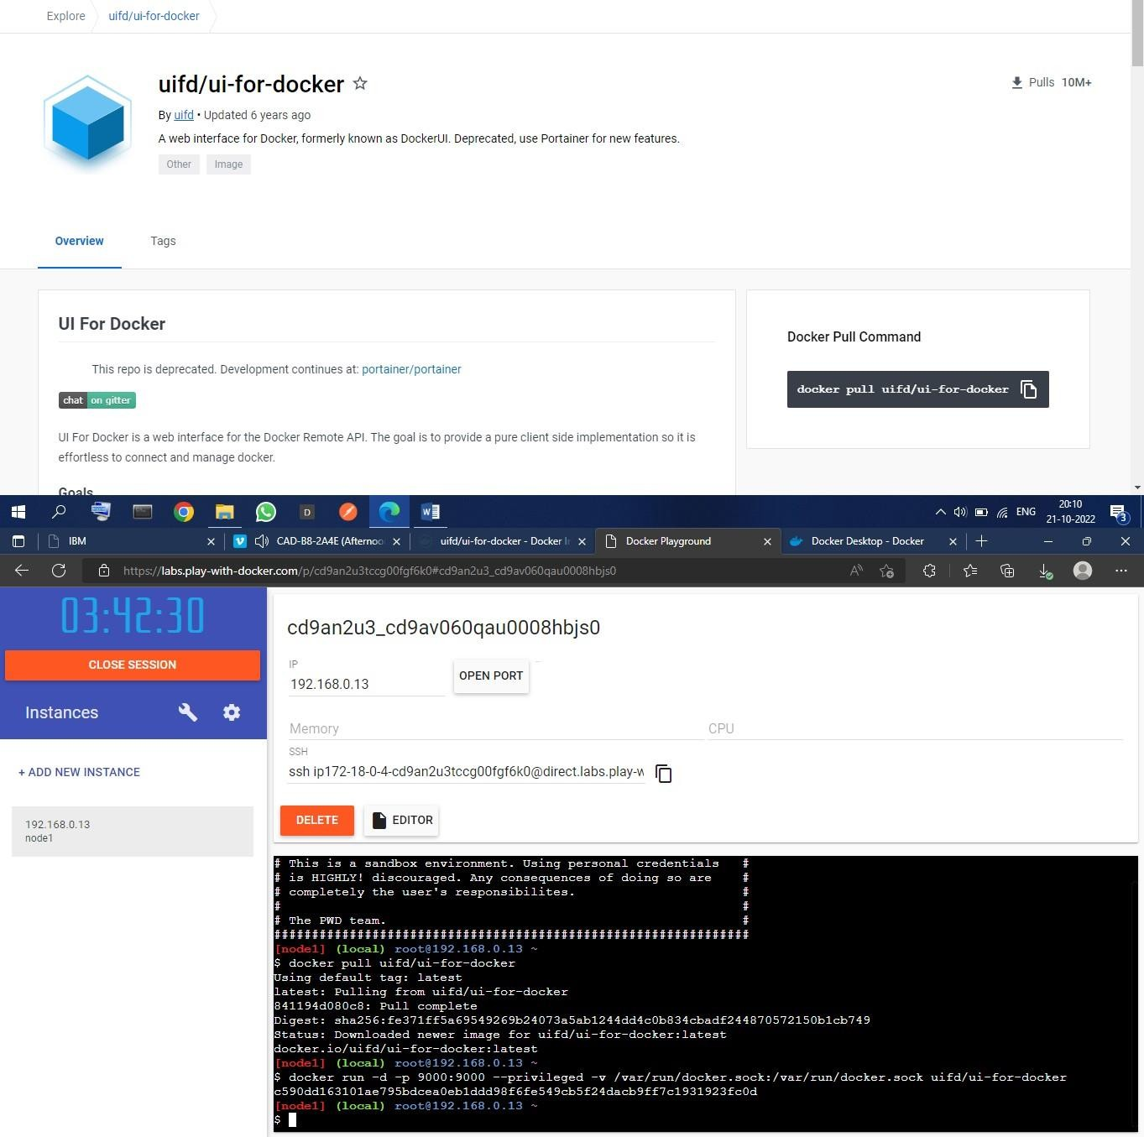

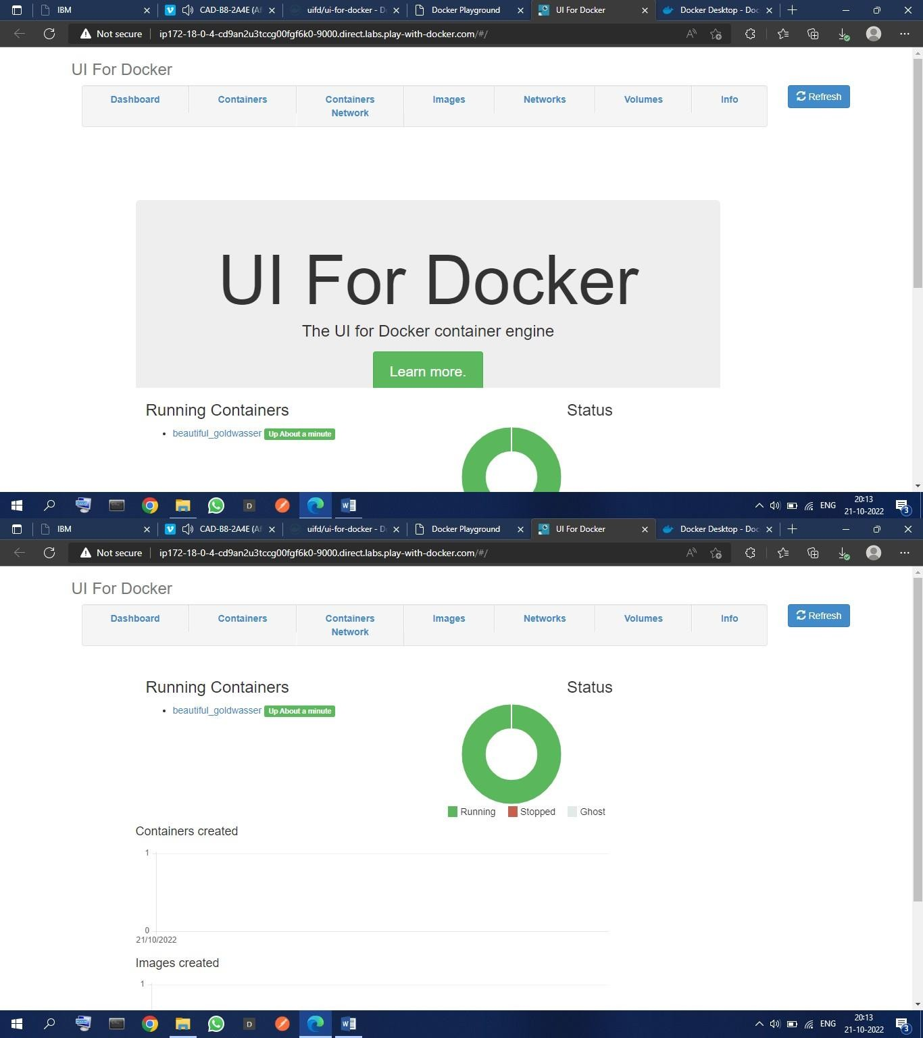

1. **Create a docker file for the job portal application and deploy it in Docker desktop application**

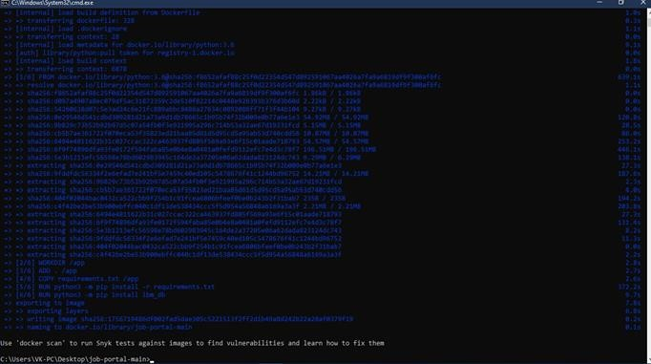

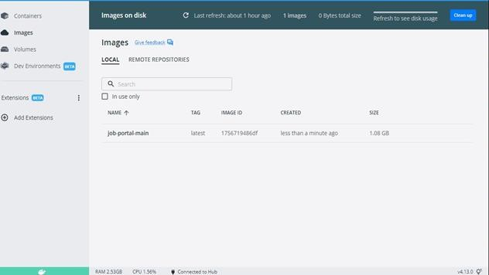

1. **Create a IBM container registry and deploy helloword app**